The Story of Farmer Clowry
By Roger Nowlan

Introduction
For those living in the Ballon-Rathoe area, the first few years after the Rebellion of 1798 are generally referred to as “troubled” ones and several stories relating to those years have survived to this day. One such story relates to a “Farmer Clowry” who was shot by “the Rebels” and, until recently, that was pretty much the extent of local knowledge as regards “Farmer Clowry”. Not even his first name had survived to the present day.
All that changed within the last year when the transcript of a letter written in 1908 by Thomas Clowry, a grandson of Farmer Clowry, found its way to Ireland and, through the miracle of the Internet, was shared with Clowry family researchers in Ireland and beyond.
At this point, other Clowry family researchers had also recently uncovered Farmer Clowry’s first name, that of his wife and their tombstone. Over the years, local historians had also documented various other pieces of information relating to the shooting of Farmer Clowry.
What follows is my attempt at piecing together a more comprehensive version of the Farmer Clowry story as known locally, shedding light on Farmer Clowry’s origins and recounting the events leading up to that fatal day and beyond as his widow and family courageously rebuilt the family’s fortunes.

Arrival of the Clowrys in Co. Carlow
According to the 1908 Clowry letter, their ancestor (McClowry) and his family crossed over to northern Ireland from Scotland at the time when “thousands of the inhabitants of that Section were driven out by the Orangemen and compelled to seek a home in some other parts”.
The exodus, as described above, no doubt refers to the “People’s Clearances” from the Highlands which started in 1770 and lasted until 1815. Further research also reveals that the earliest Clowry/McClory/McClowrey will registered in Ireland was in 1779 for a “Patrick McClowrey of Ballynaskeagh”, near Annaclone, Co. Down, suggesting that this may be the area where the Carlow Clowry ancestor first lived in Ireland. Also, knowing that the first Clowry entry in the Ballon-Rathoe parish records was made in 1784, allows us to more accurately pinpoint the date of the family’s arrival in the area as sometime between 1770 and 1784.
The 1908 letter further relates that one of the sons of the Clowry ancestor was named Jeremiah and that, once settled in Co. Carlow, as is still the custom today, neighbours began to call him Darby. This is indeed the name of “Farmer Clowry”, a name long forgotten and shrouded in mystery, that is until now.
The letter does not give any name for Darby’s parents, but, thankfully, its author does leave a clue, mentioning that the “Kellistown churchyard [was] the burial place for the older members of the Clowry family” and, indeed, when one visits this cemetery one does find a tombstone for a John Clowry (c1721-1786) and Ellis Fenlon (c1722-1788), presumably Darby’s parents, and, nearby, one for Darby (c1754-1800), his wife Anne (c1761-1831) and their son Patrick (c1789-1849).

The Clowrys of Kilkea Prosper
Upon reaching adulthood, Darby, son of the Clowry immigrant married Mary Anne Crowe who hailed from the neighbouring county of Wexford and settled on the townland of Kilkea, “immediately adjacent” to his parents’ farm.
There Darby and his wife Anne (as she was more commonly known) “built up, occupied and cultivated a farm of about 200 acres of fine, fertile land”. They were very successful and prosperous and had eight children, three sons, John, William, and Patrick, and five daughters, Mary, Elizabeth, Bridget, Anne and another whose name has been forgotten over time.

A Protestant Orangeman is Shot
In the aftermath of the Rebellion of 1798, rumours began circulating locally that Farmer Clowry and his wife had given hospitality to a band of Irish rebels seeking shelter as they attempted to escape to the Wicklow hills after the Battle of Vinegar Hill (June 1798).
Although not proven, this mere suspicion of aid to the revolutionary forces was enough to anger “the Rebels” who, in the aftermath of the Rebellion, were roaming the countryside intent on wrong-doing and seeking to settle scores.
In early 1800 the Rebels’ anger towards Farmer Clowry became more focused when a Protestant Orangeman, a neighbour of Farmer Clowry, was shot. This was the last straw. Although no proof of any involvement on the part of Farmer Clowry existed, he was nonetheless targeted by the Rebels and deemed guilty by association.
As regards the shooting of the Orangeman, history records that “a neighbour from the locality – an Orangeman named Watson – was stopped by a party of armed men as he drove home in a horse and cart near the area called the ‘Fighting Cocks’. ‘What would you wade in?’ yelled one of the group. The luckless Orangeman, through being in a state of some intoxication and not realising his grave danger, shouted back, ‘Papists blood!’. He was immediately shot dead.” (Ref: The Cullens of 1798)

Farmer Clowry is Shot
In his 1908 letter, Darby’s grandson, Thomas, son of John, describes the events of that fateful day as follows:
“The Irish rebellion occurred in the year 1798 but in that unwise uprising [Darby] or any of his relations took no part.
Immediately after the rebellion was crushed out and all was supposed to be quiet, the Orangemen formed themselves into bands of ten or twelve more or less all over the country [and] went around robbing and murdering the farmers they suspected had money.
A band of them came to [Darby]'s house one night, broke in the door to rob and murder him. When they came in [Darby’s wife, Anne,] called [each of] them by name [… and] said, ‘Do not murder my husband and I will give you all the money we have in the house.’ They had a thousand pounds in the house at that time, which they had saved to pay a year's rent for their farm to Sir Thomas Butler their landlord.
‘Give us the money,’ they cried. She did so. She gave them the box that contained the money, and as soon as they got it, they levelled their muskets at [Darby]. He picked up the youngest child, Ann, a few months old, held her on his arm and before him to protect himself from the guns, thinking they would not hurt the child. One of them struck him on the arm with a heavy sword and broke it, and the child fell to the floor. Then they fired a dozen bullets through his body and when he fell they stabbed him with their bayonets. Then they went out and fastened the door on the outside and set fire to the house.
[John], the oldest one of the family and then about 14 years old, who lay hid all the time in a corner of the room, with the aid of a cowboy drew a table up to the back wall of the house, under a small window, broke out the window and, [with] one [leg] inside and the other outside, lifted [his father’s] dead body out through it, and after him, the mother and all the children. The fire spread and burned everything in sight, all the grain and hay stacked up in the farm yard and all the farm houses. [Anne, his mother,] had at the time a dairy with a dozen or more large tubs of cream in it ready to be churned. The fire burned the tubs down until the cream flowed over and quenched it. The neighbors in the country round about seeing the fire at Darby Clowry's came in hundreds to help. They released the horses, cows, and all the stock from their houses and drove them out on the farm in time to save them.”

Farmer Clowry is laid to rest
Based upon the information on Darby’s tombstone and its location, we know that he was shot on March 6, 1800, and, as would have been customary, laid to rest a few days later, in the old Kellistown churchyard. In 1800, the new Kellistown church had not yet been built and all that stood there were the remains of an old church believed to have been built by St. Patrick and subsequently dedicated to him. An arch of the old church was still standing and nearby also stood a round tower which, unfortunately, was demolished in 1807 when the new church was built.
This was where Darby’s parents and many of his Cummins neighbours of Moanmore had been buried. The churchyard and the land on which the old church stood had indeed once belonged to the Cummins family and, already since the early 1600s, the family had been burying its dead there. In fact, just 5 years previous, in 1795, Owen Cummins, a patriarch of the Cummins family had been buried there, aged 108.

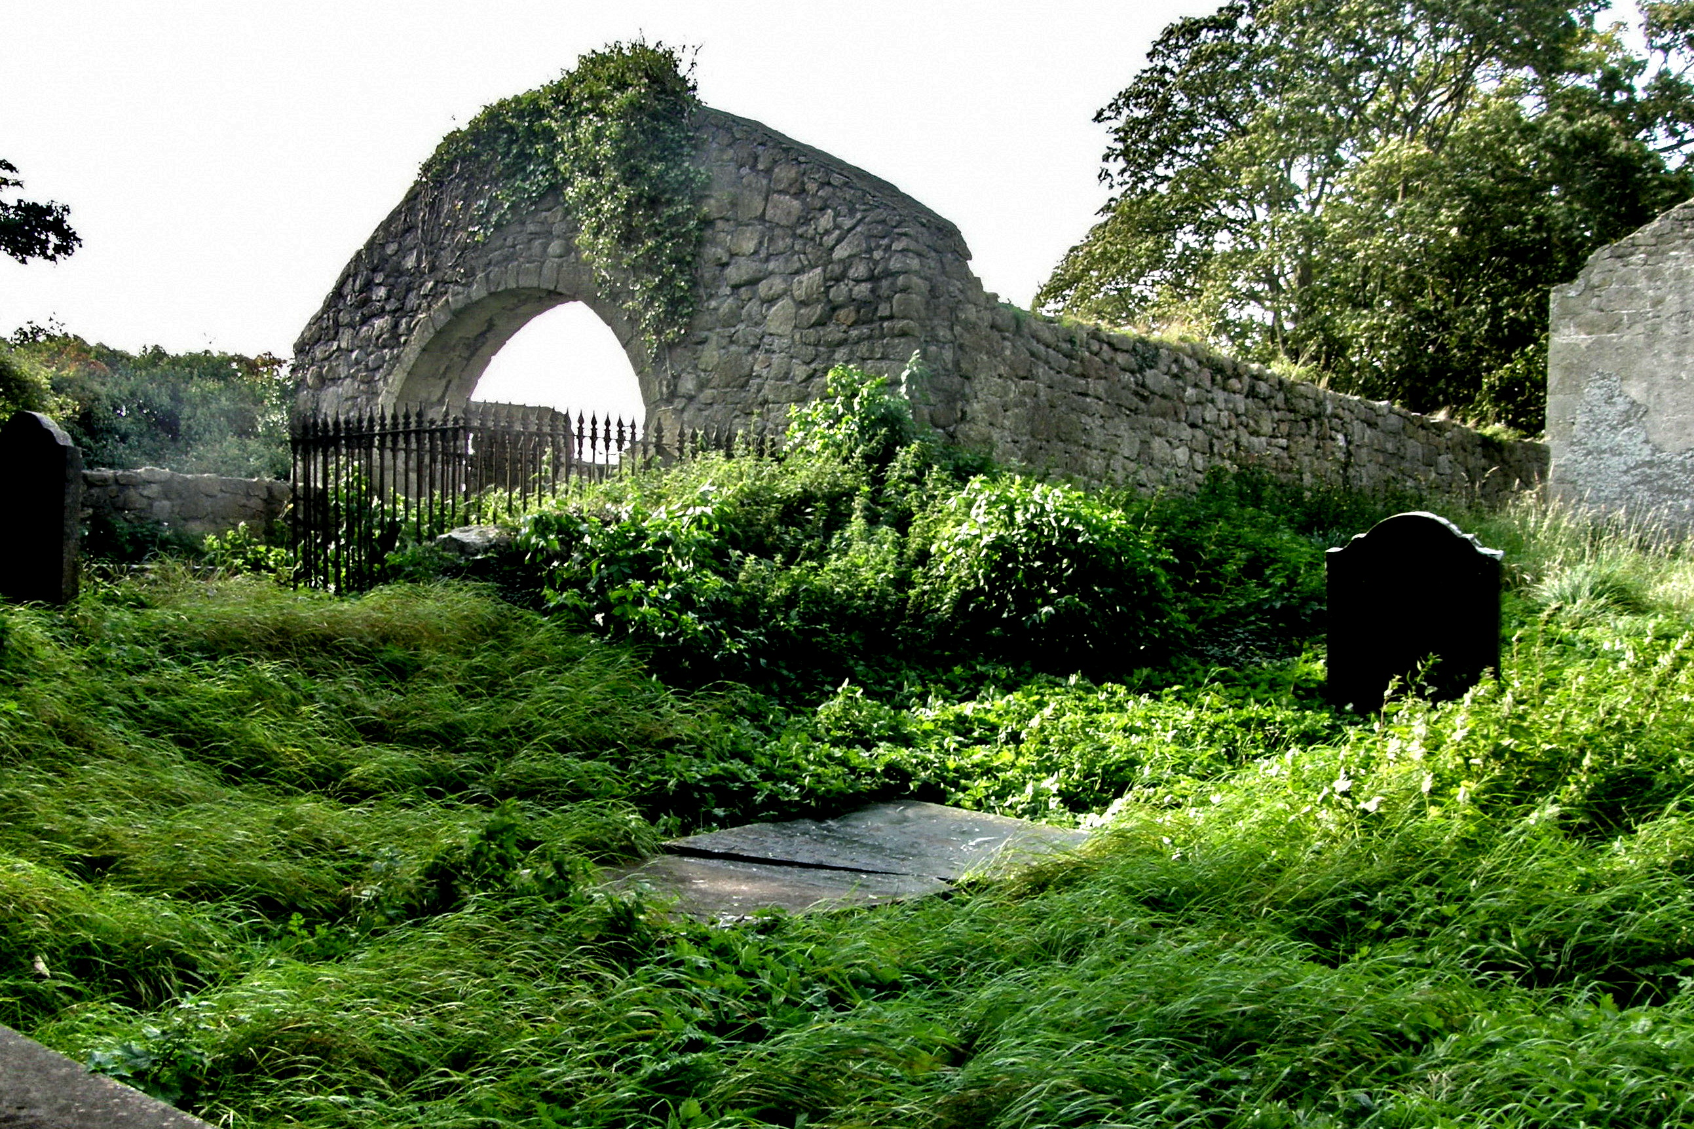
Farmer Clowry’s Last Resting Place in the Kellistown churchyard (beneath flat stone)

A Measured Response by the Authorities
On April 14, 1800, a little over a month after the shooting of Farmer Clowry, several of Darby’s neighbours were found guilty of assault. These included James, Terence, Patrick and Owen CUMMINS, Timothy MAHER and Simon NOWLAN.
These were not the men who had shot Farmer Clowry but, more than likely, some of those who had been involved in the shooting of the Protestant Orangeman near the Fighting Cocks.
“After burying the dead body of her husband [Darby], and recovering from the terrible ordeal … [Anne] went to her landlord, and told him the whole story of what had happened. He was at the same time Chief Magistrate for Carlow, and it was his duty, upon information, to issue warrants for the arrest of all murderers, robbers, and criminals of every class, and order the Sheriff to arrest them and bring them before him for trial. He swore to her that if she gave him the names of her husband’s murderers, he would have every one of them arrested and hung. She did so, … [for she knew every one of them by name, the Watson’s, the Newton’s, the Griffin’s, the Lecky’s and others, they all lived in the same neighbourhood] … But not one was ever arrested or molested.”
Although the murderers of Farmer Clowry were never brought to justice, it is difficult to imagine what negotiations might have gone on behind closed doors between the affected parties. Nonetheless, one thing is for sure, the British Authorities did recognize Darby’s death for what it was, granting, in 1804, a yearly pension of 10 pounds sterling to “Anne Clowry, widow of Darby Clowry, of the County of Carlow, who was murdered by the Rebels”.

The Family Rebuilds
After having grieved for her dead husband and sought without success to bring her husband’s murderers before justice, “Anne returned home and went to work to rebuild the houses and repair the damages. She must have been a woman of wonderful pluck and energy for in a few years she rebuilt the dwelling and all the farm houses - she kept her children well in hand, and made them do their full share in the work of rebuilding.”
When her eldest son John reached maturity and wanted to marry Anne rented the Ballytarsna farm for him and built the dwelling and all the houses on it. John married Bridget Kehoe in 1821 and they had 7 boys and 2 girls (including Thomas, the author of the 1908 letter).
When William, the second son, grew up she sent him to Carlow college to be educated where in due time he was ordained to the priesthood.
When Patrick, the youngest son, reached maturity, Anne rented for him the Ballintrane farm, and, as for John, built the dwelling and farm houses on it. The dwelling was a large two story stone mansion and the farm houses were the best in the area. Patrick married Mary Casey, a Waterford lady, and they had 4 boys and 2 girls.
The eldest daughter, Mary, married a Burns of Kilkenny, and had a houseful of children.
The second daughter whose name eluded the writer of the 1908 letter married Samuel Nolan of Knockindrane and, after his death, she married Nicholas Sheridan, a very good man and they were very successful.
Elizabeth, the next girl, married Patrick Kearney of Ballyloughan. They had a good farm and were rich and independent.
Bridget, the next one, married James Prandy of Wexford and they lived on the family’s old homestead, the one built up by her parents on the Kilkea townland, until their death, at which point James, son of her brother Patrick, took it over.
Anne, the youngest in the family, married a McDonald, a wealthy farmer of Dublin. During his studies at Maynooth College, her brother William Clowry often visited their farm.
Having raised her family and set them on their way in life, Anne died in 1831 aged 70.

The Family Moves On
In the late 1840s, the Clowry family was again thrown into turmoil. In 1847, the eldest in the family, John Clowry of Ballytarsna died, and, in 1849, at the urging of John’s brother, the Rev. William Clowry by then in Chicago, John’s widow and family joined him there where they bought a 25 acre plot and continued to farm.
While all of this was happening, John’s brother, Patrick of Ballintrane had also died, in February 1849. With his death the family’s lease on the Ballintrane lands lapsed but, fortunately, Patrick’s widow, Mary Casey, had brought much wealth into the marriage and she was able to finance the move of the family to the neighbouring townland of Kilbrickan.

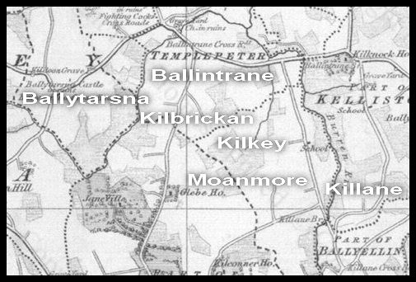

A Few Closing Remarks
What happened to Farmer Clowry was clearly the result of the actions of a few extremist “rebels” and, if there is any one lesson to be learnt from “The Story of Farmer” it is that one should beware of attributing guilt by association. Every family has its black sheep.
In writing the article, one key piece of information could not be determined with the degree of precision one would like. The author of the 1908 Clowry does indicate that his Clowry immigrant ancestor first settled on the Kilrush farm, a place commonly referred to by locals as “Crush”. On the surface, this information would seem to be sufficient to pinpoint the location of first settlement but the problem arises when one tries to find the place. As it turns out, there is no record or recollection of any place called Kilrush or Kilrush Farm in county Carlow.
However, given that author of the 1908 letter specifically says that the Kilrush farm was “immediately adjacent” to the Kilkea townland a good guess would be that it was on the Kilbrickan townland where, in the mid 1850s, stood the only other big house in the neighbourhood. Another possibility for the location might also be the Kilmaglin townland where, according to one account, Farmer Clowry was shot.
In the article, I did not address the issue of Farmer Clowry’s siblings as further research is required before definite family links can be established. However, the following have been tentatively identified as siblings of Darby Clowry (c1754-1800):
- an unnamed brother who lived on the Kilrush farm and had at least 3 sons, “James, Robert and Thomas … all fine, handsome young men” with whom Darby’s eldest son John (b. 1786) was best friends during his youth
- a James Clowry who married a Mary Shortall in 1784 and died before 1793 when his widow remarried, marrying my ancestor James Nowlan from the Killane area
- a Thomas Clowry who married a Mary Cullen (c1762) , daughter of Edmund Cullen of Craanaha and lived on the Ballybromhill townland not far from Kilkea
- an Edward Clowry (c1742-1802) who married an Ellen Gorman (c1761-1836) and whose son Patrick, after having emigrated to America (Albany, NY) had a tombstone erected in a Myshall cemetery to the memory of his parents and siblings.

Credits
Special thanks go out to all those who helped to make the writing of this story possible:
- Cathy Bordenaro of Illinois who transcribed the hand-written version of the 1908 letter which had been passed down to her by her great-aunt, Elizabeth Alleluia Byrne, who, in turn, had received it from her mother, Nellie Byrne née Kehoe, who had received it from her mother, Eliza Kehoe née Clowry, sister of Thomas, the author of the original 1908 letter
- John Clowry of Castledermot who put Cathy Bordenaro in touch with other Clowry family researchers in Ireland, most notably Trevor Clowry of Dublin who made a transcribed version of the 1908 letter available to Carlow family researchers via the Carlow mail-list (IGP website)
- Veronica Shorten of Athy (formerly of Linkardstown) who located the old Clowry family tombstones in the Kellistown churchyard and made sense of the weathered text found on them.

